Task – 1: Creating a key vault in azure
Step 1: Search for key vaults in the search bar and select create to view this screen, as the screenshot displays all the basic details are filled.
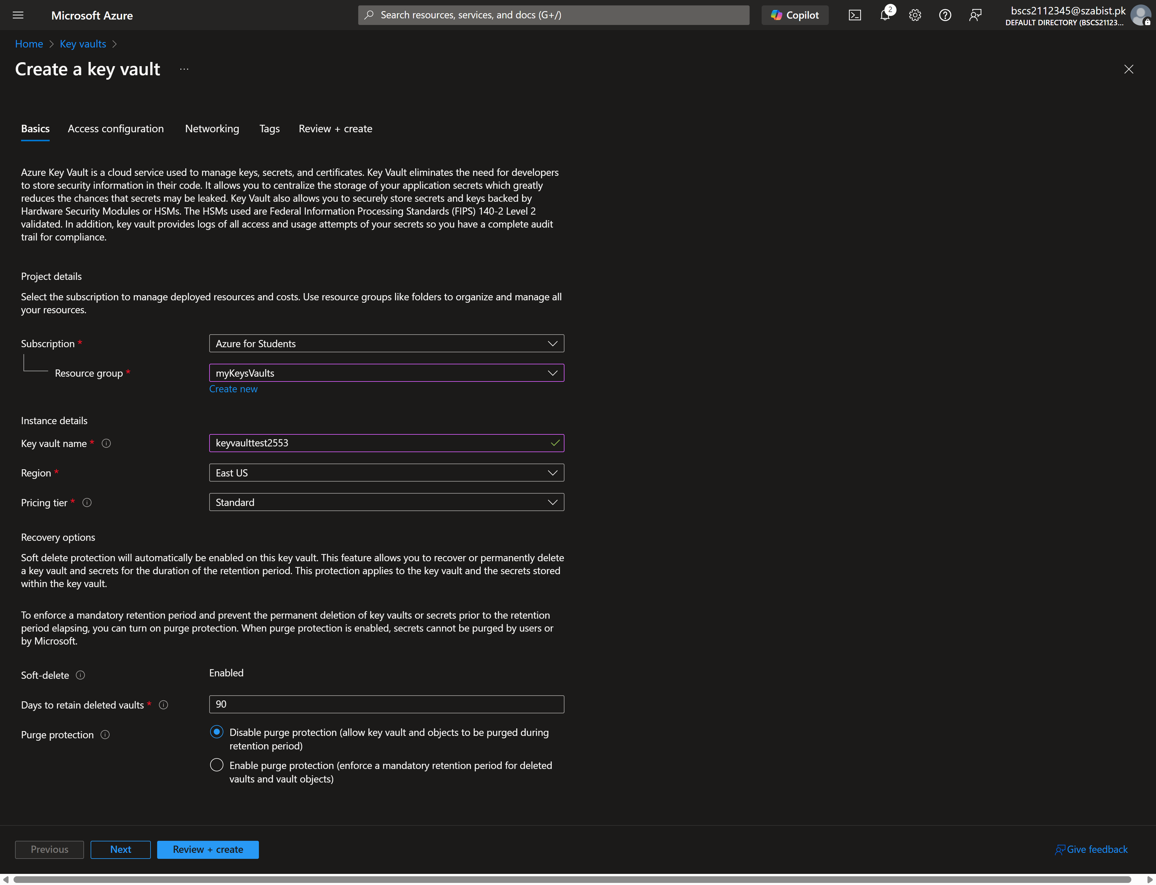

Step 2: After filling in the basic details, we click “Review + create” to review the configuration and finally click “Create” which than brings us to this screen verifying creation success.
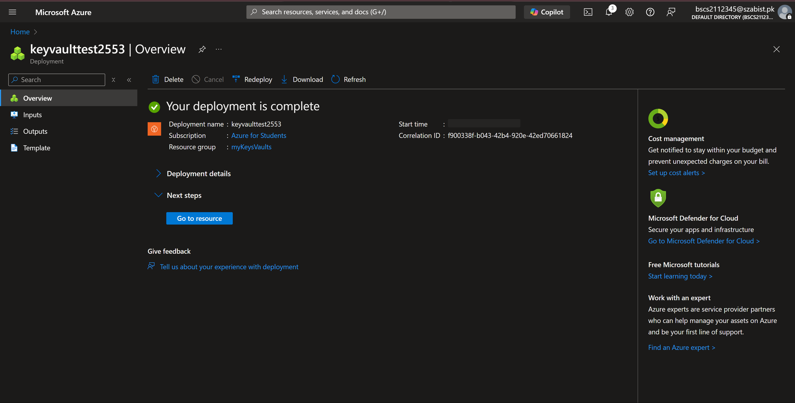

Task 2: Adding a secret in key vault
Step 1: Under settings tab in key vault, I’ve chosen the secret menu and selected to create a new secret. I’ve filled in the name and the secret value as displayed
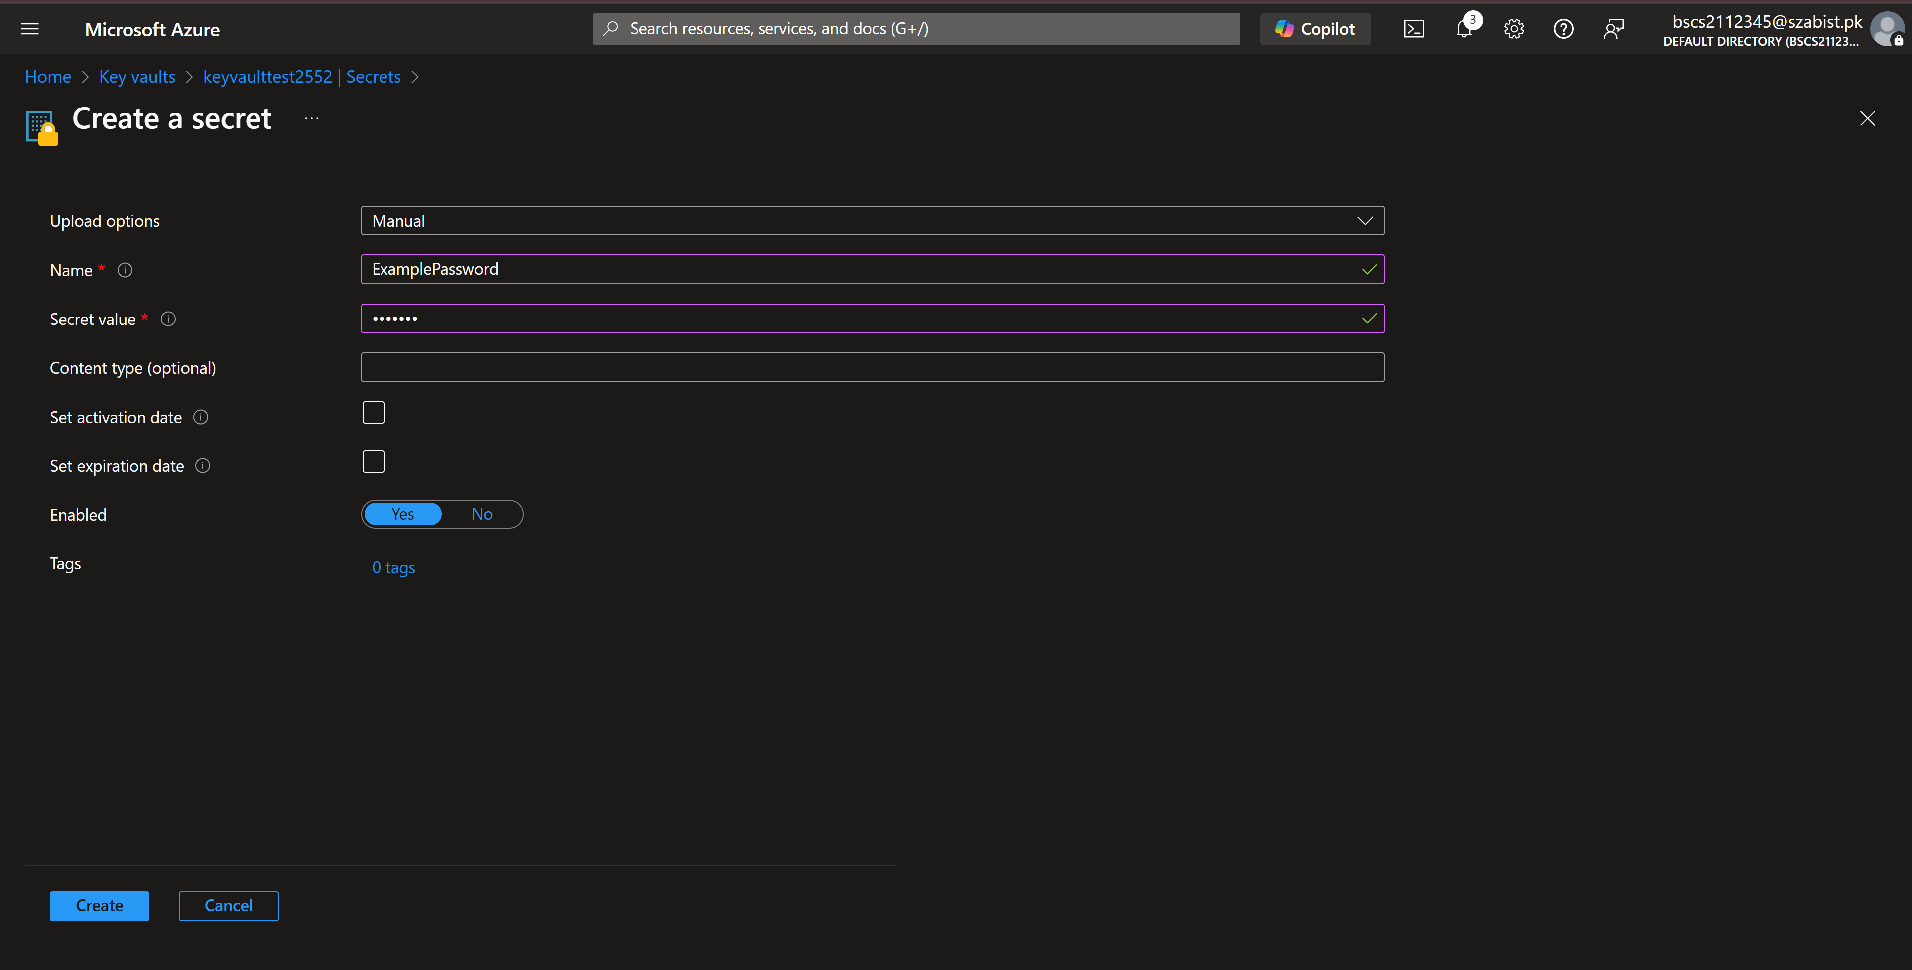

Step 2: After successfully creating the secret, we can see the status and the version by clicking on the secret name in secrets list.
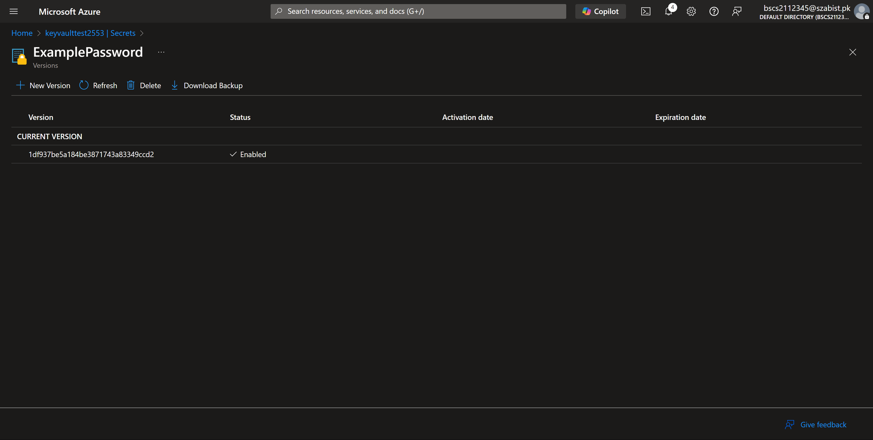
Step 3: Accessing the secret value and unhiding it to see the actual value.
